**PROJECT DESIGN PHASE-2**

|  |  |
| --- | --- |
| Team ID | NM2023TMID02667 |
| Project name | How to add google analytics to a website |
| Date | 3 November 2023 |

**Determine the requirements(customer journey maps)**

customer journey analytics is “the process of tracking and analyzing the way customers use combinations of channels to interact with an organization.

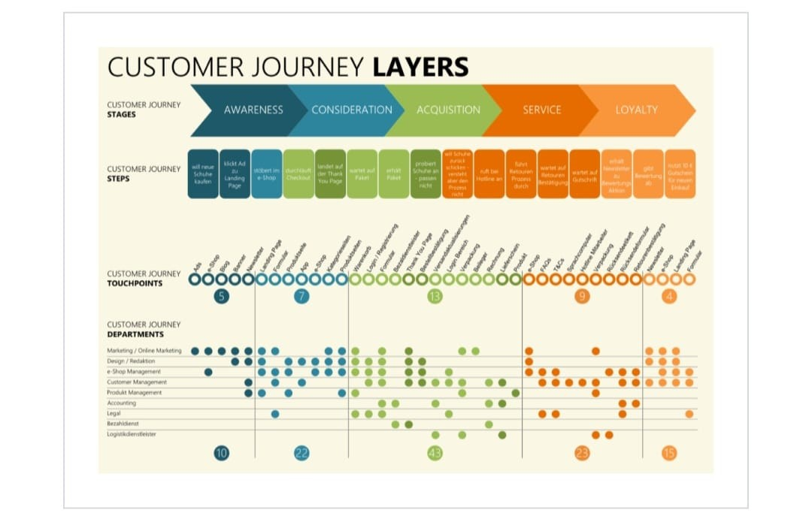

You receive customers’ information throughout their relationship with your business, both online and offline. Then it sits in your CRMs, analytics, emails, etc. The data tells you which channels lead consumers to your website, what content they browse, or even which store they visit most often.

By merging your customers’ data, you’ll be able to create profiles to understand who they are and grasp their expectations and preferences. Later, you’ll enrich those profiles with new details whenever consumers contact your organization.

**Requirement Analysis (functional, operational, Technical)/Flow charts**

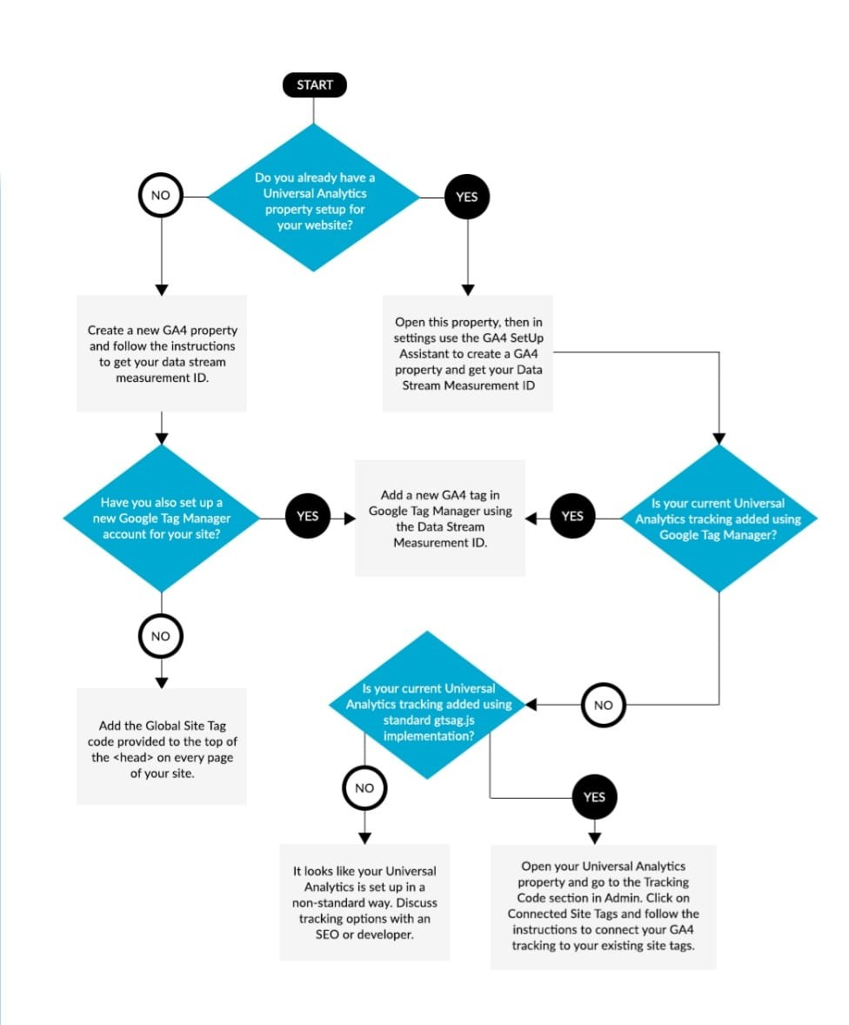

Access to Website's Source Code: You need access to the source code of the website to make necessary changes. Determine if you have the necessary permissions or credentials to access and modify the website files.

**Technical Architecture**

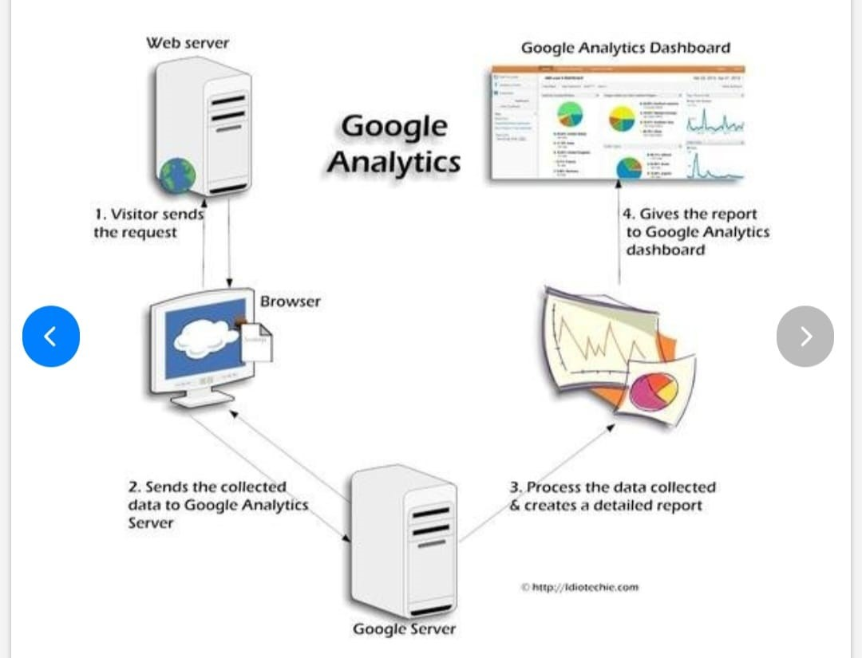

When any visitor accesses any section of your website, a request is made to the webserver to display the page. The webserver process the request and sends back the response to the browser. When the visitor's browser loads the page, it executes the javascript GA tracking code present in that webpage.

Google Analytics will extract user cookie values. It updates and creates the cookies as necessary and sends the request to Google Analytics server where the data is processed. After the processing all the data then forms the part of the Google Analytics Report. This data is finally available for user's view in the user's Dashboard**.**

**Open source frameworks**

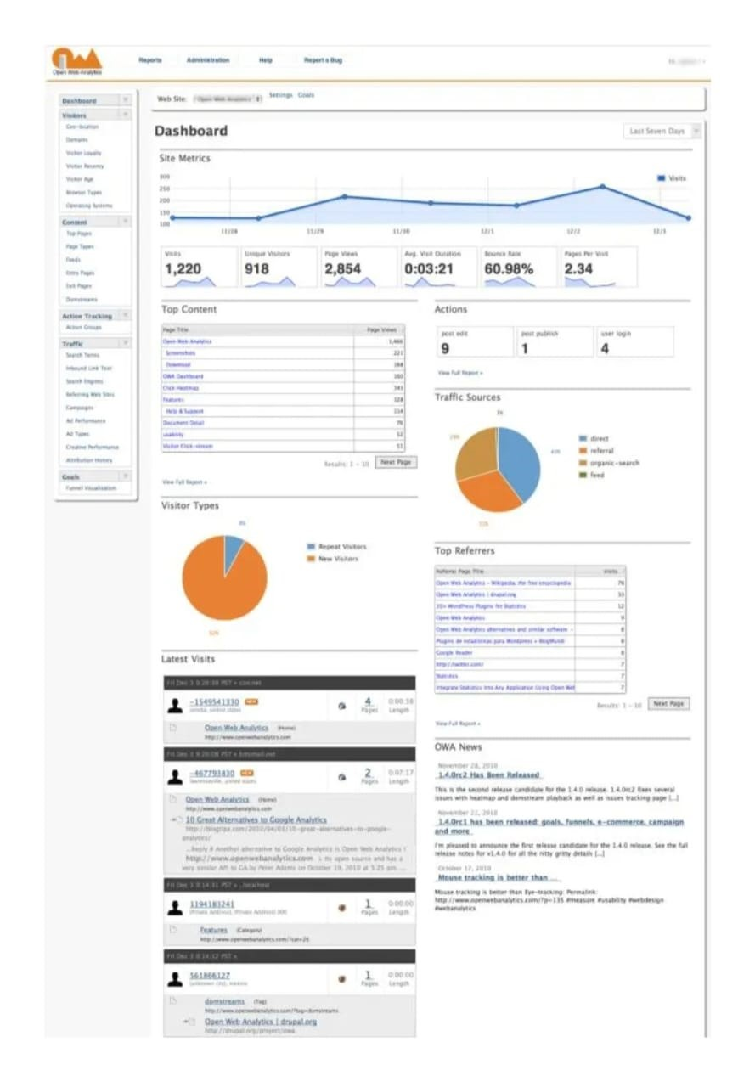

**Third party API’S**

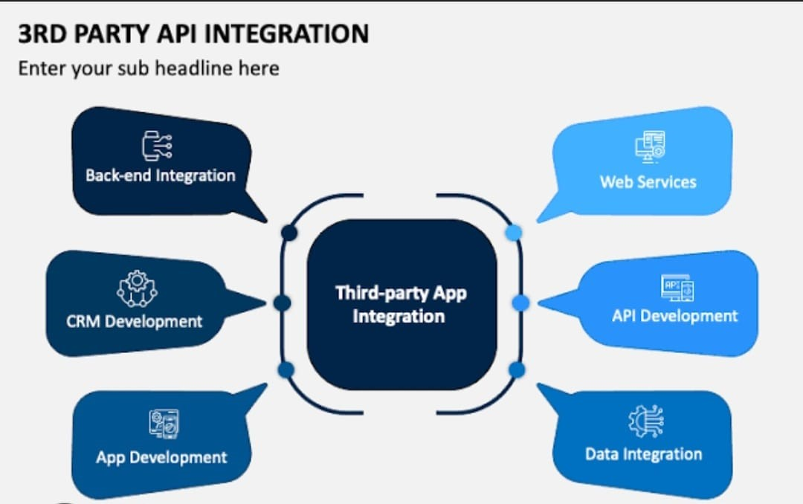

Go to the Google Analytics website (<https://analytics.google.com/>).

Sign in with your Google account.Set up a new account:

Click on "Admin" in the lower-left corner of the page.

In the "Account" column, click on the dropdown menu and select "Create Account."

Fill in the required information:

Provide an Account Name. This could be the name of your website or your company name.

Choose what you want to measure. Select "Web" for a website.

Enter the website name, URL, industry category, and reporting time zone.

Get your tracking code:

After setting up the account, you'll be given a tracking code snippet.

Copy this tracking code and paste it into the HTML code of your website. Place it just before the closing </head> tag on every page you want to track.

Verify the tracking code installation:Go back to Google Analytics and click on "Admin."

Under the "Property" column, click on "Tracking Info" and then "Tracking Code

**Cloud deployment**

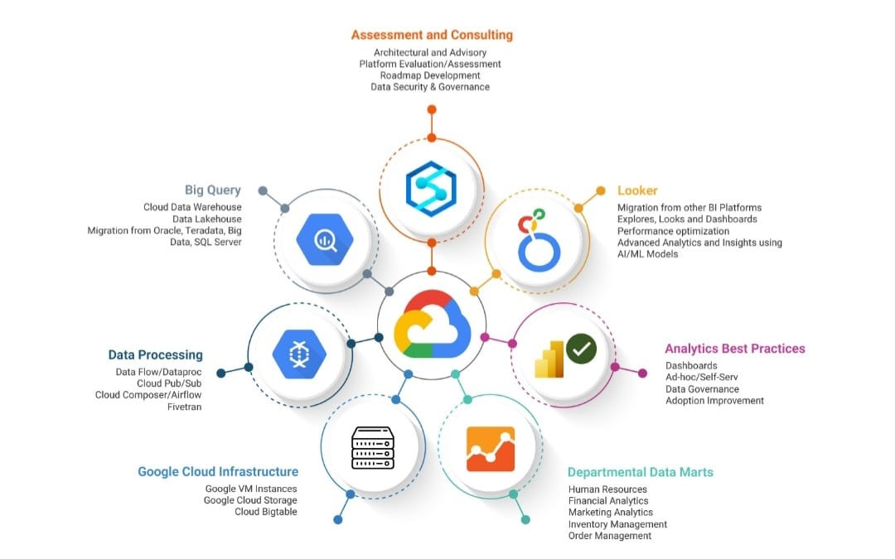

As organizations go digital, data collection speeds up while the economic value of data decreases. To help you escape this pitfall, let us put your focus back on analytics so that you continue discovering and capturing new insights from data; Insights that can bring scalability and flexibility to your information strategy.

Jade’s Google Cloud Analytics Services is your gateway to moving away from a point-solution-based strategy. With our flexible deployment models, you get the speed and scalability to govern and act upon your enterprise data, realizing faster time to value.